Calloway County  Young and Adult  Farmer Program  Calloway County High School  2108 College Farm Road  Hazel, KY 42071  Johnnie Stockdale  Instructor  270-293-1003  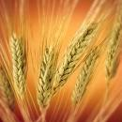  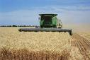  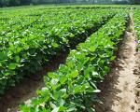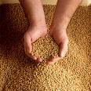 |  | 7/31/2026  It’s time to mark your calendars for our Young and Adult Farmer Classes for January and February.  Where:  Calloway County High School  Agriculture Department  2108 College Farm Road  Murray, KY 42071  When: 7 pm  Nov. 10  Managing Alternative Feed Sources – Todd Powell, U.K. Extension Services  Forage Management – Johnnie Stockdale, Agriculture Instructor  Nov. 17  Cattle Herd Health Issues – Dr James Lyons, Mineral Wells Animal Clinic  Nov. 23  TBA  Dec. 1  TBA  The Calloway County Extension Service, the Calloway County Cattlemen’s Association, and the Calloway County Young and Adult Farmer Program sponsor classes.  Everyone is encouraged to take advantage of this opportunity and to invite other interested producers to be our guests.  Thank you,  Johnnie Stockdale

